**Lily Setup - Intellij Ultimate – Download Zip**

***Note: These instructions are based off of having the most up to date version of Intellij Ultimate***

1. Click **‘Clone or download’** on GitHub and select **‘Download Zip’**

1. Locate the downloaded zip file and Extract it if necessary.
2. Open up Intellij and select **‘Open or Import’**

***Note: depending on the version you have the menu may look different, but it should still have **‘Import’** on it***

1. **LOCATE** the extracted zip file and **OPEN** it



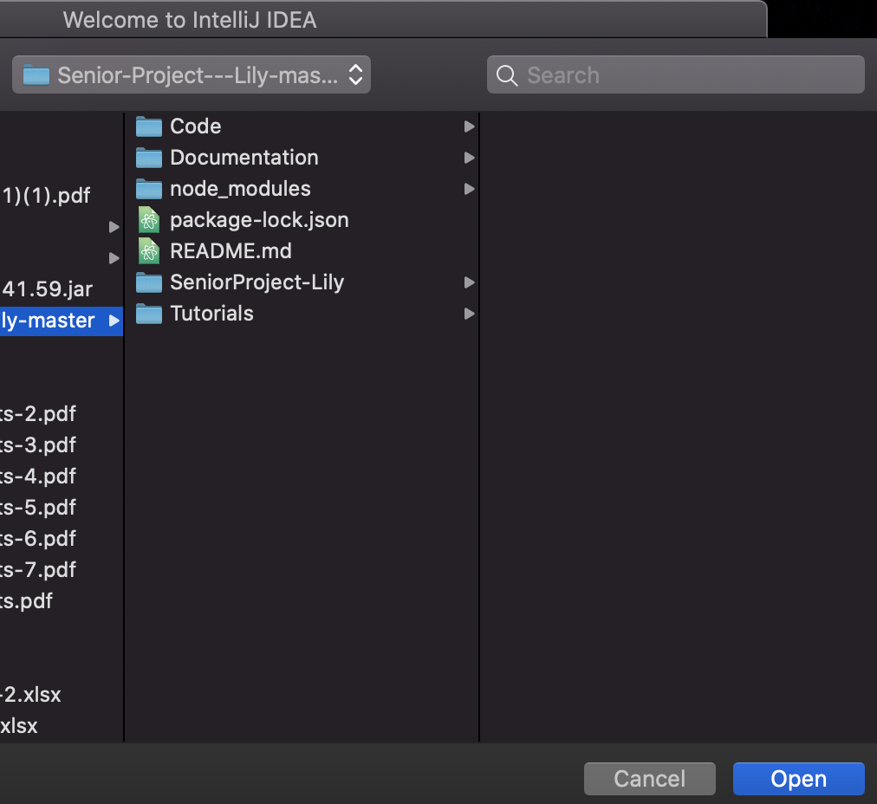

***Note: Open the folder with all of the contents. If you save the folder under Code/1234/TopDawg/**Senior-Project---Lily-master**, open the **Senior-Project---Lily-master** folder. If it is saved as downloads/Senior-Project---Lily-master/**Senior-Project---Lily-master,** open the **Senior-Project---Lily-master** folder that has the contents in it***

1. Let the project index (could take a while – view this at bottom of screen)

**\*\*\***Note: While project is indexing a few things should pop up**\*\*\***

1. Click **‘Import’** when **‘Maven build script found’** pops up at bottom right of screen

***Note: If you have a Mac or your Intellj is set up to automatically to import maven projects then ignore this step***

1. Click **‘Configure’** when **‘Frameworks Detected’** pops up at bottom right

***Note: You **DO NOT** have to keep everything selected being that you will only run our webpage, unless of course you decide to run other example pages that comes with the Tomcat setup. You do not even have to select the web.xml that is selected in this image***

1. If the project is still indexing continue to let it do so, and even if it is not indexing, check out the project structure. It should look like this:

1. **Time to configure**
   1. Expand the ‘**Web Apps’** folder, right click ‘**index.jsp’** and select ‘**Run ‘index.jsp’.** If **step 16a** happens **SKIP** to **step 16b**, if **nothing** happens proceed to **step 9b**, and if the ‘**Run/Debug Configurations’** window popup, **SKIP** to **step 10**

* 1. If **‘Run ‘index.jsp’** is not available, then open the **‘index.jsp’** file and in the top right corner click **‘Add Configuration …’** and the ‘**Run/Debug Configurations’** window will pop up.

1. On the left menu, scroll and find **‘Tomcat Server’** and select **‘Local.’** You may have to click the **‘+’** sign in the top left to get the options to pop up

1. Beside the **‘Application Server:’** text box, click the **‘Configure…’** button and the **‘Application Servers’** window will pop upA picture containing screenshot, holding, looking, woman

   Description automatically generated
2. Beside the **‘Tomcat Home:’** text box in the **Application Servers’** window, click the folder icon

1. Navigate to the **‘node_modules’** folder in the project folder, so **wherever you saved the zip file**. Click on the Tomcat folder that has **your OS name** on it. Ex: {Project_Lily}/node_modules/tomcat_**yourOS.** Once you are done, click the **‘OK’** button.

1. A warning message should appear at the bottom of the **‘Run/Debug Configurations’** pop-up box. **Click ‘Fix’.**

1. Select the **‘Senior-Prject---Lily:Web’** artifact, click **‘Apply’** and then **‘OK’**

1. **Time to run ‘index.jsp’!**
   1. Click the green **‘Run’** button

If the following page pop up the first time you run the project, head to **step 16b**

* 1. Head back to Intellij. Your ‘**index.jsp’** file should be open (if not, open it). While the server is still running open the file in the browser that you desire by hovering over the code. These options (or more) should pop up in the corner. Click whichever you like.

* 1. **‘Index.jsp’** should now be loaded.

1. There is no admin login so if you do not have access to a student banner ID then you will not be able to see all of the features unless you go to **ashwood.ncat.com** and login with **‘admin’** for both username and password.

If you had any complications with these steps it may be due to the version of Intellij you are using. Again, these instructions are based off of having the most up to date version of **Intellij Ultimate**